Persistent Systems Limited, Pune

Job Scheduling in Networked Manufacturing
Using Game Theory
Use Case Template

10/14/2011

v. 1.0

Approvals Signature Block

Project Responsibility | Signature | Date
Project Guide (Internal)
Prof. A. S. Shingare
Project Guide (External)
Mr. Jigar Shah
Documentation Leader

Table of Contents

1 .General Information 3
1.1 Version Control 3
1.2 Information Details 3

2.Use Case Template 4

Use Case 1 4
Use Case 2 5
Use Case 3 6

3.Use Case Specifier List 7

3.1 Use Case ID and Name 7

4. Use Case Definition List 7

4.1 Actors 7
4.2 Description 7
4.3 Preconditions 7
4.4 Post conditions 7
4.5 Normal Flow 7
4.6 Alternate Flow 8
4.7 Includes 8
4.8 Priority 8

General Information

Informational Item | Information
Document Title | Use Case Template
Version | 1.0
Author
Project Name | Job Scheduling in Networked Manufacturing using Game Theory
Project Phase | Phase 1
Project Iteration | 1

Version Control

Date | Version | Description | Author
Oct-14-2011 | 1.0 | Created

Information Details

Informational Item | Information
File Name | /tmp/lo/0000.doc
Last Saved On | Saturday October 14 2011
Last Saved By | Oct-14-2011
Number of Pages | 8

Use Case Template

USE CASE 1: Job Scheduling in Networked Manufacturing

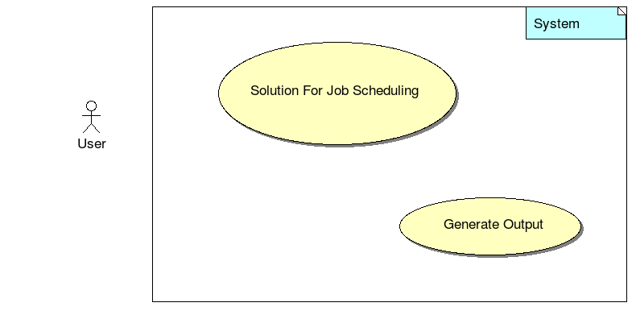

Use Case 1 | Job Scheduling in Networked Manufacturing
Goal | Develop and implement a system for job sc
Purpose | Develop algorithm for job scheduling in networked manufacturing using Genetic Algorithm on various platforms
Preconditions
Success Condition | Algorithm works successfully and output is delivered in optimal time
Failed Condition | Algorithm fails under particular input case
Post conditions | Output generated and displayed in screen
Primary Actors | User
Trigger | This use case will be initiated when user wants to get the solution for job scheduling in networked manufacturing
DESCRIPTION | Step | Basic Course of Action
 | 1 | Design algorithm
 | 2 | Accept input about distributed jobs in networked manufacturing from user
 | 3 | Execution of code
DESCRIPTION | Step | Error Scenario
 | 2 | Negative input

USE CASE 2: Genetic Algorithm

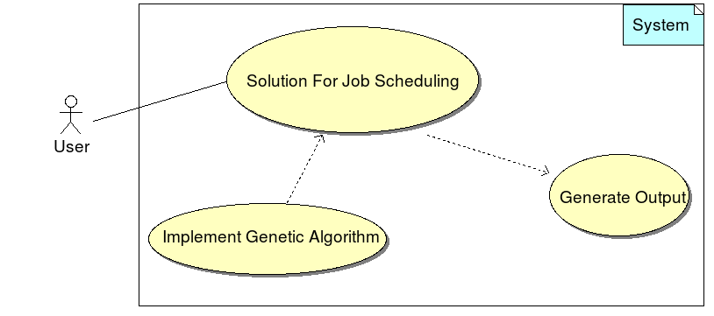

Use Case 2 | Genetic Algorithm
Goal | To Solve Job Scheduling using Genetic Algorithm
Purpose | To implement job scheduling using genetic algorithm successfully
Preconditions | Existence of algorithm
Success Condition | Algorithm gives Success
Failed Condition | Algorithm fails, unexpected output
Post conditions | Output is successfully obtained
Primary Actors | User
Trigger | This use case will be initiated when user wants to get the solution for job scheduling in networked manufacturing
DESCRIPTION | Step | Basic Course of Action
 | 1 | Generate genetic algorithm parameters
 | 2 | Execution of genetic algorithm to find optimal solution
DESCRIPTION | Step | Error Scenario
 | 2 | Precision of output due to use of genetic algorithm

USE CASE 3: Generate Output

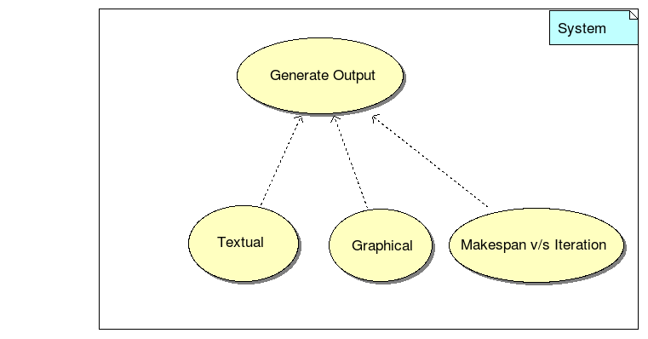

Use Case 3 | Generate Output
Goal | To display output
Purpose | To display output in proposed format
Preconditions | Solution obtained successfully from implementation
Success Condition | Output displayed
Failed Condition | Output is no displayed as expected
Post conditions | Output will be generated and displayed on screen
Primary Actors | User
Trigger | This use case will be initiated when user wants to get the solution for job scheduling in networked manufacturing
DESCRIPTION | Step | Basic Course of Action
 | 1 | Accept output from implementation of algorithm
 | 2 | Get textual output
 | 3 | Get Graphical output
 | 4 | Compare makespan v/s Iteration
DESCRIPTION | Step | Error Scenario
 | 1 | Output not obtained from implementation
 | 2 | Output not displayed in proposed format

Use Case Specifier List

Use Case ID name
ID | Name
1 | Job Scheduling in Networked Manufacturing
2 | Genetic Algorithm
3 | Generate Output

Use Case Definition List

Actors
Main actor is User who will use this implementation to solve job scheduling problem in networked manufacturing

trigger
Use Case 1 | This use case will be initiated when user wants to get the solution for job scheduling in networked manufacturing
Use Case 2 | This use case will be initiated when user wants to get the solution for job scheduling in networked manufacturing
Use Case 3 | This use case will be initiated when user wants to get the solution for job scheduling in networked manufacturing

Preconditions
Use Case 1
Use Case 2 | Existence of algorithm
Use Case 3 | Solution obtained successfully from implementation

Post conditions

Use Case 1 | Output generated and displayed in screen
Use Case 2 | Output is successfully obtained
Use Case 3 | Output will be generated and displayed on screen

Normal Flow

Use case 1
- Design algorithm
- Accept input about distributed jobs in networked manufacturing from user
- Execution of code

Use case 2
- Generate genetic algorithm parameters
- Execution of genetic algorithm to find optimal solution

Use case 3
- Accept output from implementation of algorithm
- Get textual output
- Get Graphical output
- Compare makespan v/s Iteration

Alternative Flows

Includes
The Use Case 3 - Generates output includes giving all 3 types output
- Textual
- Graphical
- Analytical

Priority
Use Case | Priority
Job Scheduling in Networked Manufacturing | 1
Genetic Algorithm | 2
Generate Output | 3

